Attachment 2 Xiyuan Hotel accommodation form

Room Reservation Form
Arriv Date： |  |  |  | Arriv Flight： |  |  |  |  |  | ETA：
Dept Date： |  |  |  | Dept Flight： |  |  |  |  |  | ETD：
Last Name |  | First Name |  |  |  | Country |  |  |  | Confirmation No.
Room Type |  |  |  |  |  | Room Rate
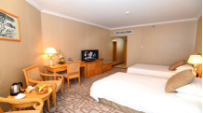 |  |  | □Standard Room(Twin bed) （11-18 Floor） |  |  | 580RMB / room·day  (excluding breakfast)  650RMB / room·day  (including single personbreakfast)  720RMB / room·day  (including two persons breakfast)
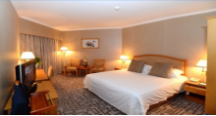 |  |  | □Standard Room(King size bed )  （11-18 Floor） |  |  | 600RMB / room·day  (excluding breakfast)  670RMB / room·day  (including single personbreakfast)  740 RMB / room·day  (including two persons breakfast)
Note: The above price is only for the conference discounted prices (Including 15% service charge)
Payment Instruction
□On guest own account |  | □On company account |  |  |  |  |  | □Room only on company account
Guaranteed Credit Card： |  |  |  |  |  |  | □Visa □Master □Diners  □Amex □JCB
No & Validity：
Booked By：
Contact No/Email：
Return Fax No.：
Confirmation Letter ： |  | Yes |  |  |  |  |  | No
Please confirm above information and inform the contact
Xiyuan Hotel Contact: | Ms.Wu Fangfang |  |  |  | Address: |  |  |  | 1 Sanlihe Road, Haidian District, Beijing
Email: | wufangfang@xiyuanhotel.com.cn |  |  |  | Office Fax: |  |  |  | 86-10-68314644
Note：For reservations，please fill in the form and email to wufangfang@xiyuanhotel.com.cn.

